
American International University- Bangladesh (AIUB) Faculty of Engineering (EEE)

Course Name: | Digital Logic Circuits | Course Code: | EEE 3101
Semester: | Summer 24-25 | Assignment Name: | OBE Assignment
Marks: | 30 | Term: | Final
Faculty: | DR. SHAHRIYAR MASUD RIZVI | Section | O
Student Name: | FARIHA MEEM | Student ID: | 22-49251-3 | Serial :
Submission Date: | 20-09-2025 | Department: | CSE

COs  /  CLOs  Number | COs/CLOs Statements | K | P | A | Assessed  Program  Outcome  Indicator | BNQF  Indicato  r | Teaching-  Learning Strategy
CO2 | Show a digital system with conflicting requirements of a complex engineering problem. | 3 | P1,P2,  P6 | - | P.a.3.C3 | FS.1 | OBE Assignment  (Final Term)

X | Y | - | M | E | T | R | O | - | Z
2 | 2 | - | 4 | 9 | 2 | 5 | 1 | - | 3
Instructions Related to Use Variables:
Note that this problem uses the variables M, E, T, R, O, which are the digits of your student ID (XY-METRO-Z).
Any value in student ID comes ‘0’ will be replaced by ‘(X+Y+Z)’

Marking Rubrics (to be filled by Faculty):

Complex Problem | Task | Assessment Criteria |  | Evaluation Criteria |  |  | Marks
P1, P2, P6 | I. | Outline the necessary  steps of the block diagram | Excellen  t (2) | Good  (1.5) | Averag e (1-.5) | Poor  (0)
P1, P2, P6 | I. | Outline the necessary  steps of the block diagram | All the steps have been identified and are in the correct sequence | Not all the steps have been  identified  and in the correct sequence | Few steps have been identified  and in the correct sequence | All the steps have been found in the wrong sequence.
P1, P2, P6 | I. | FSM design and HDL Code | Excellen  t (6-5) | Good  (4.5-3  ) | Averag e (2.5-.5) | Poor  (0)
P1, P2, P6 | I. | FSM design and HDL Code | All the designs were accurate and working | Not all the designs were accurate and working | Few designs were accurate and working | All the designs were wrong and not working
P1, P2, P6 | II. | Design counter with the  necessary  diagram and also DAC | Excellen t  (12-10) | Good  (9.5-6  ) | Averag e (5.5-3) | Poor  (2.5-0)
P1, P2, P6 | II. | Design counter with the  necessary  diagram and also DAC | Circuit design is correct and complies with the problem | Circuit design is correct, but does not comply with the problem | Circuit design is incorrect and does not comply with the problem | Circuit design is wrong and does not comply with the problem
P1, P2, P6 | III. | Design of System with timer circuit | Excellen  t (5-4) | Good  (3.5-2  ) | Averag e (1.5-1) | Poor  (0.5-0)
P1, P2, P6 | III. | Design of System with timer circuit | Design is correct and complies with the  requirements, with no or minor calculation errors. | Design is correct and complies with the  requirements, but with major  calculation errors. | Design has major flaws which does not comply with the requirements, but with minor calculation errors. | Design has major flaws which does not comply with  the requirements, with major  calculation errors.
P1, P2, P6 | IV. | Limitations of the developed system | Excellen  t (5-4) | Good  (3.5-2  ) | Averag e (1.5-1) | Poor  (0)
P1, P2, P6 | IV. | Limitations of the developed system | Provides limitations and analyzes the performance correctly | Provides limitation only | Provides improper limitations and  performance analysis | Provides no limitation  and gives no  performance analysis
Marks Obtained:
Recently, while traveling by metro in Dhaka, you noticed the automatic crowd management system at the platform entry. For safety reasons, only 10 passengers are allowed on the platform at a time. A yellow boundary line is marked before the platform gates.

- Each passenger’s ticket card has an RFID sensor that detects entry.
- If more than 3 passengers cross the yellow line simultaneously, an alarm should trigger.
The alarm should be activated only when and as long as this condition is met.
- A synchronous counter keeps track of the number of people inside the platform. In a day a maximum of 20 tickets is issued.
- A 555 timer is used to generate the clock for both counter and alarm.
- The FSM states are encoded as the following: (IDLE → CHECK → OPEN → CLOSE).
- The platform monitoring system sends the current passenger count to the control room in analog form via DAC, while the ADC is used to read sensor inputs.

- Sketch the block diagram of the system showing RFID sensors, ADC, synchronous counter, FSM, DAC, and alarm unit.
- Demonstrate how the FSM transitions between IDLE, CHECK, OPEN, and CLOSE states depending on counter values. The FSM transitions from OPEN to CLOSE after 20 tickets are issued. Also, show Verilog HDL code for the system. [Hint: Use a done-type signal from the counter to transition from OPEN to CLOSE state.]
- The alarm should trigger if more than 3 passengers cross simultaneously. Show the simplified Boolean expression for this condition. Show using only NAND gates. Show how this logic controls the timerN.
- Show the 555-timer circuit for the alarm with frequency = P5 Hz and duty cycle = Q% [where P = M+E+T+R+O, Q = 100 – P]. If P5 is not within 250–4500 Hz, set f = 400 Hz. Select the most suitable capacitor from 50 μF, 250 μF, or 470 μF. [Hint: If P=20, then P5=205.]
- Show how the DAC output voltage represents the passenger count for 5 and 10 passengers (assume 4-bit DAC, Vref = 5 V).
- Illustrate limitations of this developed metro safety system.

Assignment: Final Term.

Answer to the question no. 1:

- The block diagram of the Automatic Crowd Management System is:
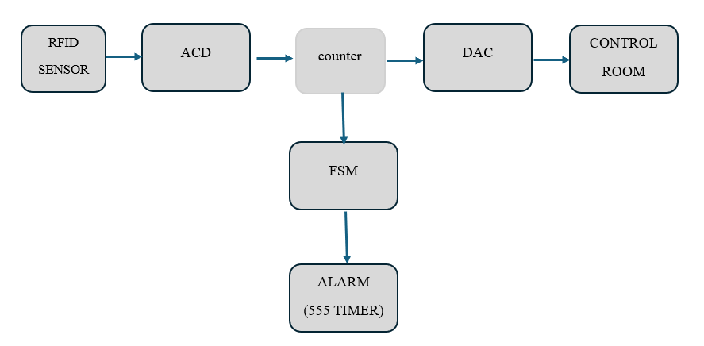

Explanation of the Blocks:
- RFID Sensor: Detects passenger entry.
- ADC: Reads RFID sensor inputs.

- Synchronous Counter: Counts passengers inside the platform. Here, a maximum of 10 passengers are allowed at a time.

- DAC: Converts counter value to analog voltage for sending to the control room.

- FSM: Stands for Finite State Machine, which mainly controls gate state transitions: IDLE, CHECK, OPEN, CLOSE.

- Alarm: Triggers when 3 or more passengers cross simultaneously.

Answer to Question No. 2

The FSM (Finite State Machine) has 4 states: IDLE, CHECK, OPEN, and CLOSE.
State Transitions:
*IDLE → CHECK: Transition occurs when an entry pulse is detected.

*CHECK → OPEN: If passenger count < 10 and alarm = 0.

*CHECK → IDLE: If passenger count = 10 or alarm = 1.

- OPEN → CLOSE: After allowing one passenger entry and incrementing the ticket counter.

- CLOSE → IDLE: If done = 0 (ticket issued < 20).

- CLOSE → CLOSE/Lock: If done = 1 (ticket issued = 20).

- 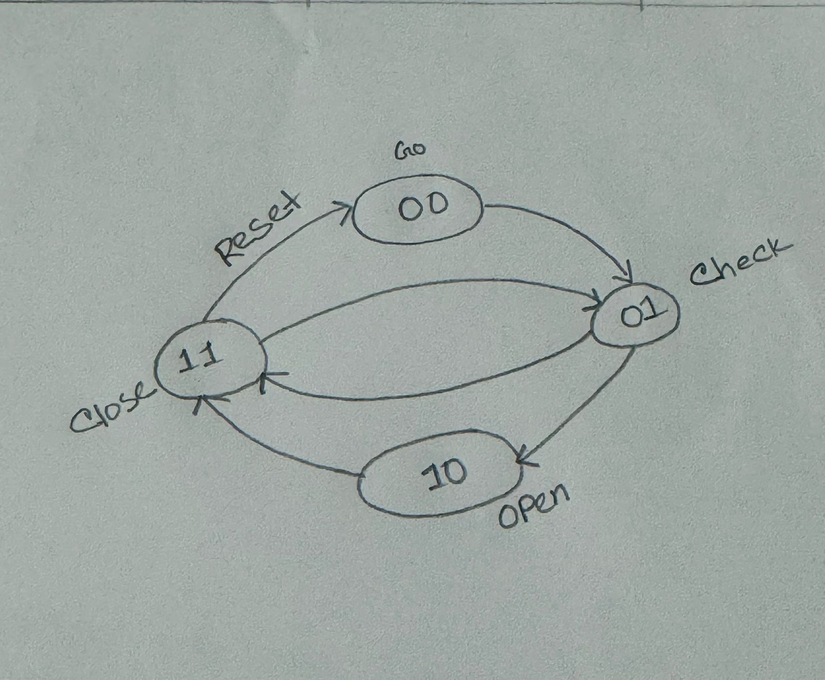
Fig: Draw this clock
State Transition Table:

Present State | Condition | Next State | Output
IDLE | entry_pulse = 0 | IDLE | 0
IDLE | entry_pulse = 1 | CHECK | 0
CHECK | alarm = 1 OR count = 10 | IDLE | 0
CHECK | count < 10 OR done = 0 | OPEN | 1
OPEN | – | CLOSE | 1
CLOSE | done = 0 | IDLE | 0
CLOSE | done = 1 | CLOSE/Lock | 0

- Verilog HDL code:

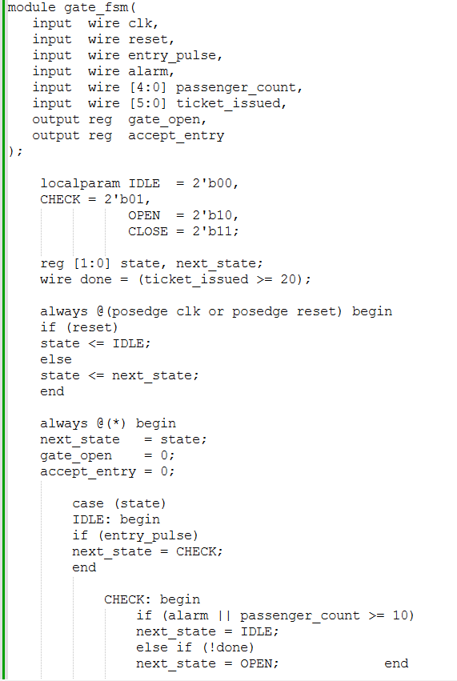

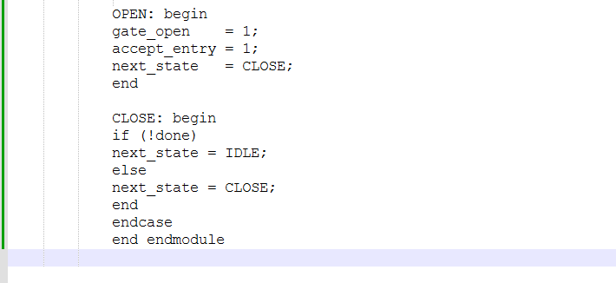

Answer to the question no. 3

If more than 3 passengers cross simultaneously (with 4 sensors S₃, S₂, S₁, S₀), the alarm triggers only when all 4 sensors = 1.
Here is given,
Alarm = S₃ · S₂ · S₁ · S₀
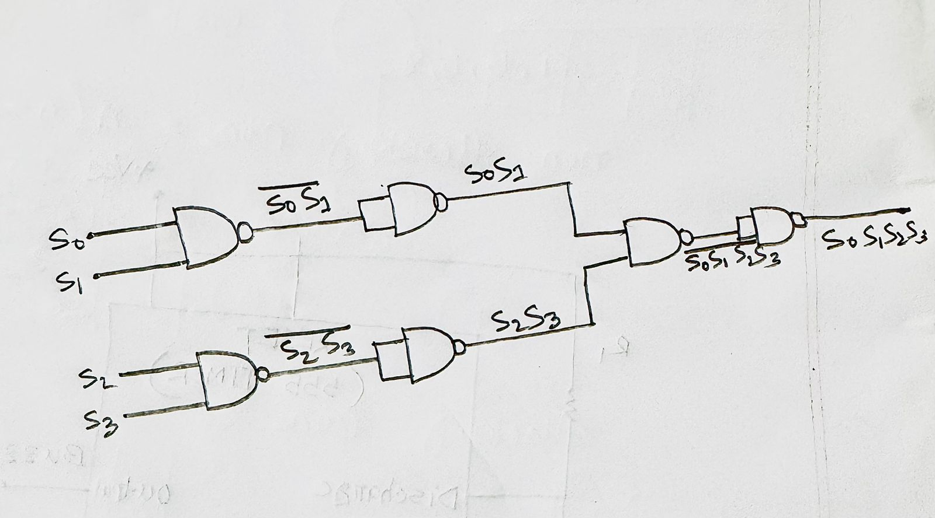

Fig 1: NAND gate design
Controlling 555 Timer:
Here, the alarm signal is connected to the RESET pin of the 555 timer.
*When alarm = 1, RESET = HIGH, the 555 timer is enabled and the buzzer turns on.

*When alarm = 0, RESET = LOW, the 555 timer is disabled and the buzzer is off.

Answer to the question no. 4

Here,
XY − METRO − Z as
22 - 49251 -3

Now,
We get,
frequency, P5 = (M + E + T + R + O)5
= (4 + 9+ 2 + 5 + 1)5
= 21 × 5
= 105 Hz
[ P = (4 + 9 + 2 + 5 + 1) = 21 ]
∴ Q = 100 − P
= 100 − 21
= 79
∴ Duty cycle = 79 %
Now,
Tf = 1/f = 1/400 = 2.5 × 10⁻³ s (since 120 Hz < 250 Hz, f is set to 400 Hz)
∴ TH = 0.79 × 2.5 × 10⁻³ = 1.975 × 10⁻³ s
∴ TL = 0.21 × 2.5 × 10⁻³ = 5.25 × 10⁻⁴ s
We know that,

TH = 0.693 C1 (R1 + R2)
∴ R1 + R2 = 1.975 × 10⁻³ / (0.693 C1)
If C1 = 50 μF
∴ R1 + R2 = 1.975 × 10⁻³ / (0.693 × 50 × 10⁻⁶) = 56.99 Ω
If C1 = 250 μF
∴ R1 + R2 = 1.975 × 10⁻³ / (0.693 × 250 × 10⁻⁶) = 11.39Ω
If C1 = 470 μF
∴ R1 + R2 = 1.975× 10⁻³ / (0.693 × 470 × 10⁻⁶) = 6.06 Ω
Resistors with low values choose are not perfect since there will be very large currents and for this power will be wasted. So, we will the 50 μF capacitor as it gives the highest (R1 + R2) value.
Now, C1 = 50 μF
∴ TL = 0.693 C1 R2
∴ R2 = 5.25 × 10⁻⁴ / (0.693 × 50 × 10⁻⁶) = 15.15 Ω
∴ TH = 0.693 C1 (R1 + R2)
∴ R1 = 1.975 × 10⁻³ / (0.693 × 50 × 10⁻⁶) – 15.15 = 5− 15.15 = 10.16 Ω

- Given below the design:
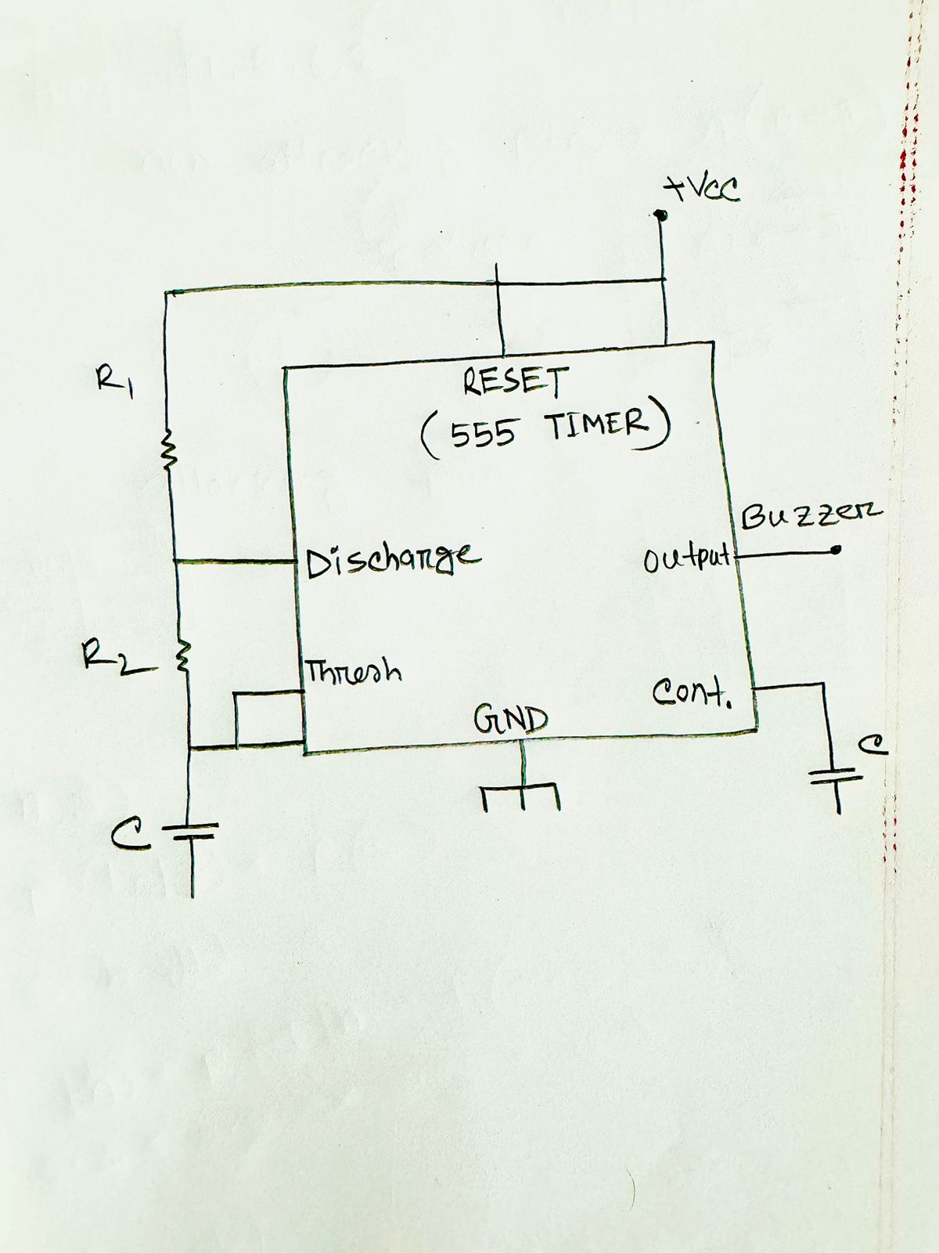
FIG: THE 555 TIMER

Answer to the question no. 5
Here,
The analog output is proportional to the digital input code.
We know that,
For an n-bit DAC, the maximum code is 2^n - 1.
That corresponds to the maximum analog output equals Vref.
So,
Vout / Vref = N / (2^n - 1)
It is a 4-bit DAC, Vref = 5V.
1 LSB = Vref / (2^n - 1) = 5 / (2^4 - 1) = 5/15 = 0.33V
For 5 passengers,
Vout = (5 / 15) × 5 = 1.67V
For 10 passengers,
Vout = (10 / 15) × 5 = 3.33V
Each increment of the counter increases the DAC output by ≈ 0.33V (1 LSB).

Answer to the question no. 6

"Although the developed metro safety system successfully manages platform crowd control, it still has several limitations that may affect its overall reliability and performance, as outlined below."

1. RFID Reading Errors: The RFID sensor may fail to read a passenger's ticket card as affected by metal interference, electromagnetic noise or may read the same card multiple times which will negatively affect system accuracy.

2. Simultaneous crossing Detection: The logic for detecting more than three passengers crossing at the same time may produce false alarms if passengers walk closely together but not truly simultaneously.

3. Fixed capacity Limitation: The counter is designed to allow a maximum of 10 passengers at a time and 20 tickets per day, which may not be suitable for peak hours or special events with high capacity.

4. Analog Communication Limitations: Using a low-resolution DAC to send passenger count to the control room may result in inaccurate monitoring due to analog noise or voltage drop.

5. Power Dependency: During power outages the system may stop functioning unless a reliable UPS or backup power system is provided.

6. Human factors and scalability: The system cannot distinguish between adults, children or luggage. It only counts entries but not actual persons. The system is also designed only for one platform gate.

THANK YOU

